programming and structures using c

Assignment 1

Write algorithm and draw flowchart

**1.Find a student average mark given mark1 and mark2**

Algorithm :

Step1- start

Step2- declare variables mark1,mark2 and Avg

Step3-read variables mark1 and mark2

Step4- add mark1 and mark2 and divide by 2 and assign the result to Avg

Avg<--(mark1+mark2)/2

Step5- Display Avg

Step6- stop

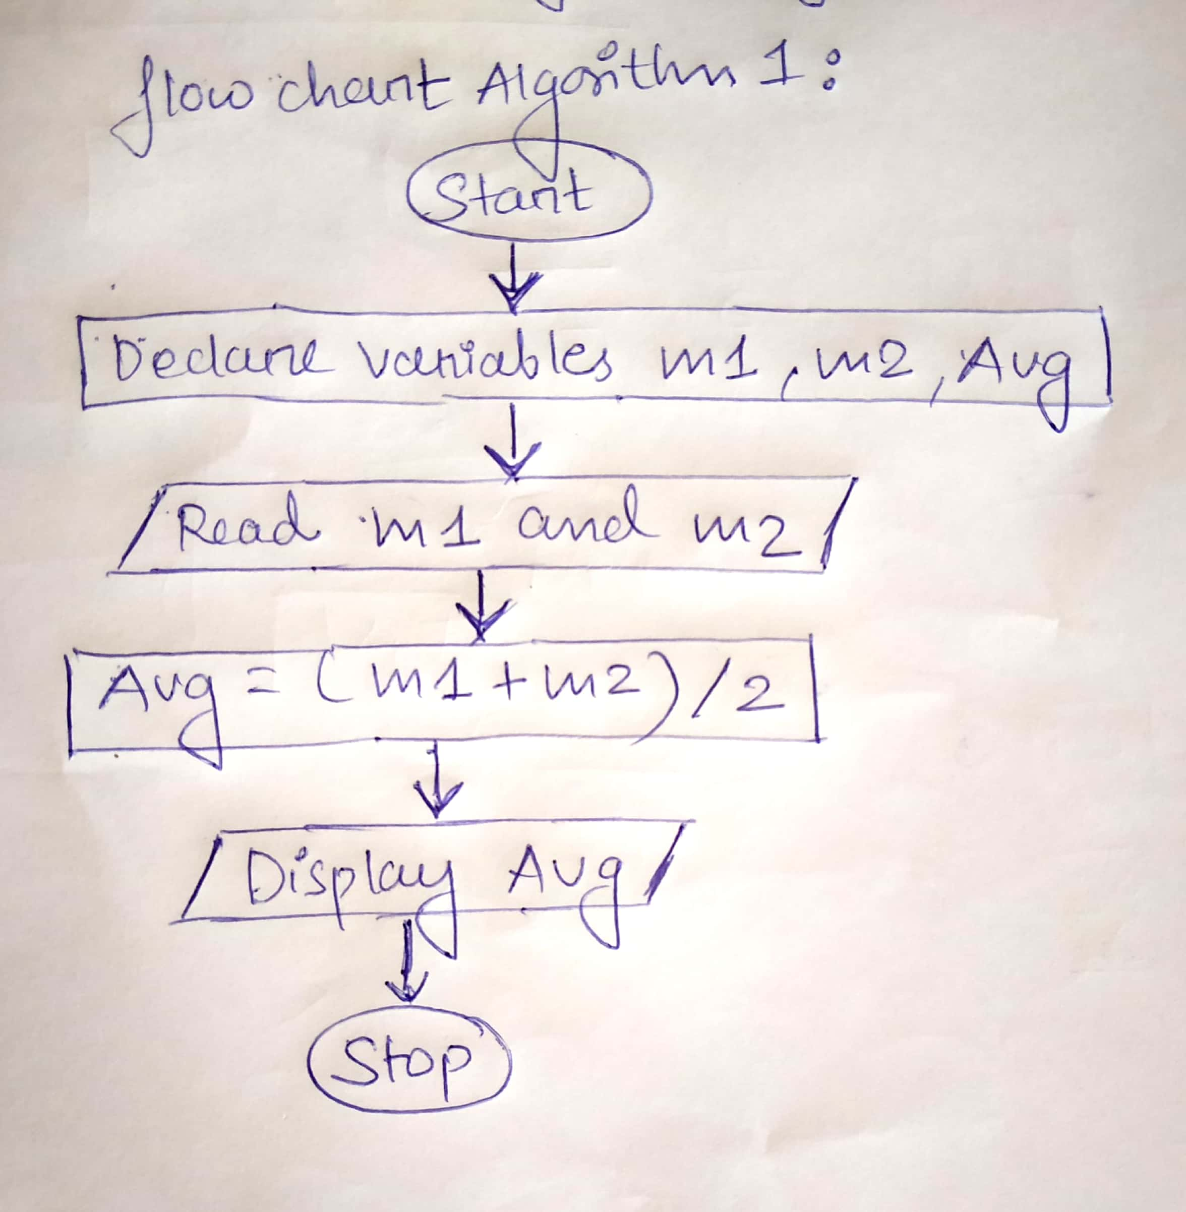

**2. calculate the total fine charged by library for late return books . the charge is 0.20 INR for 1 day**.

Algorithm :

Step1- start

Step2- declare variables days, charge, fine

Step3- initialise variable  charge=0.20

Step4- read variable days

Step5- multiply days and charge and assign the result to fine

Fine <-- days*charge

Step6- display fine

Step7- stop

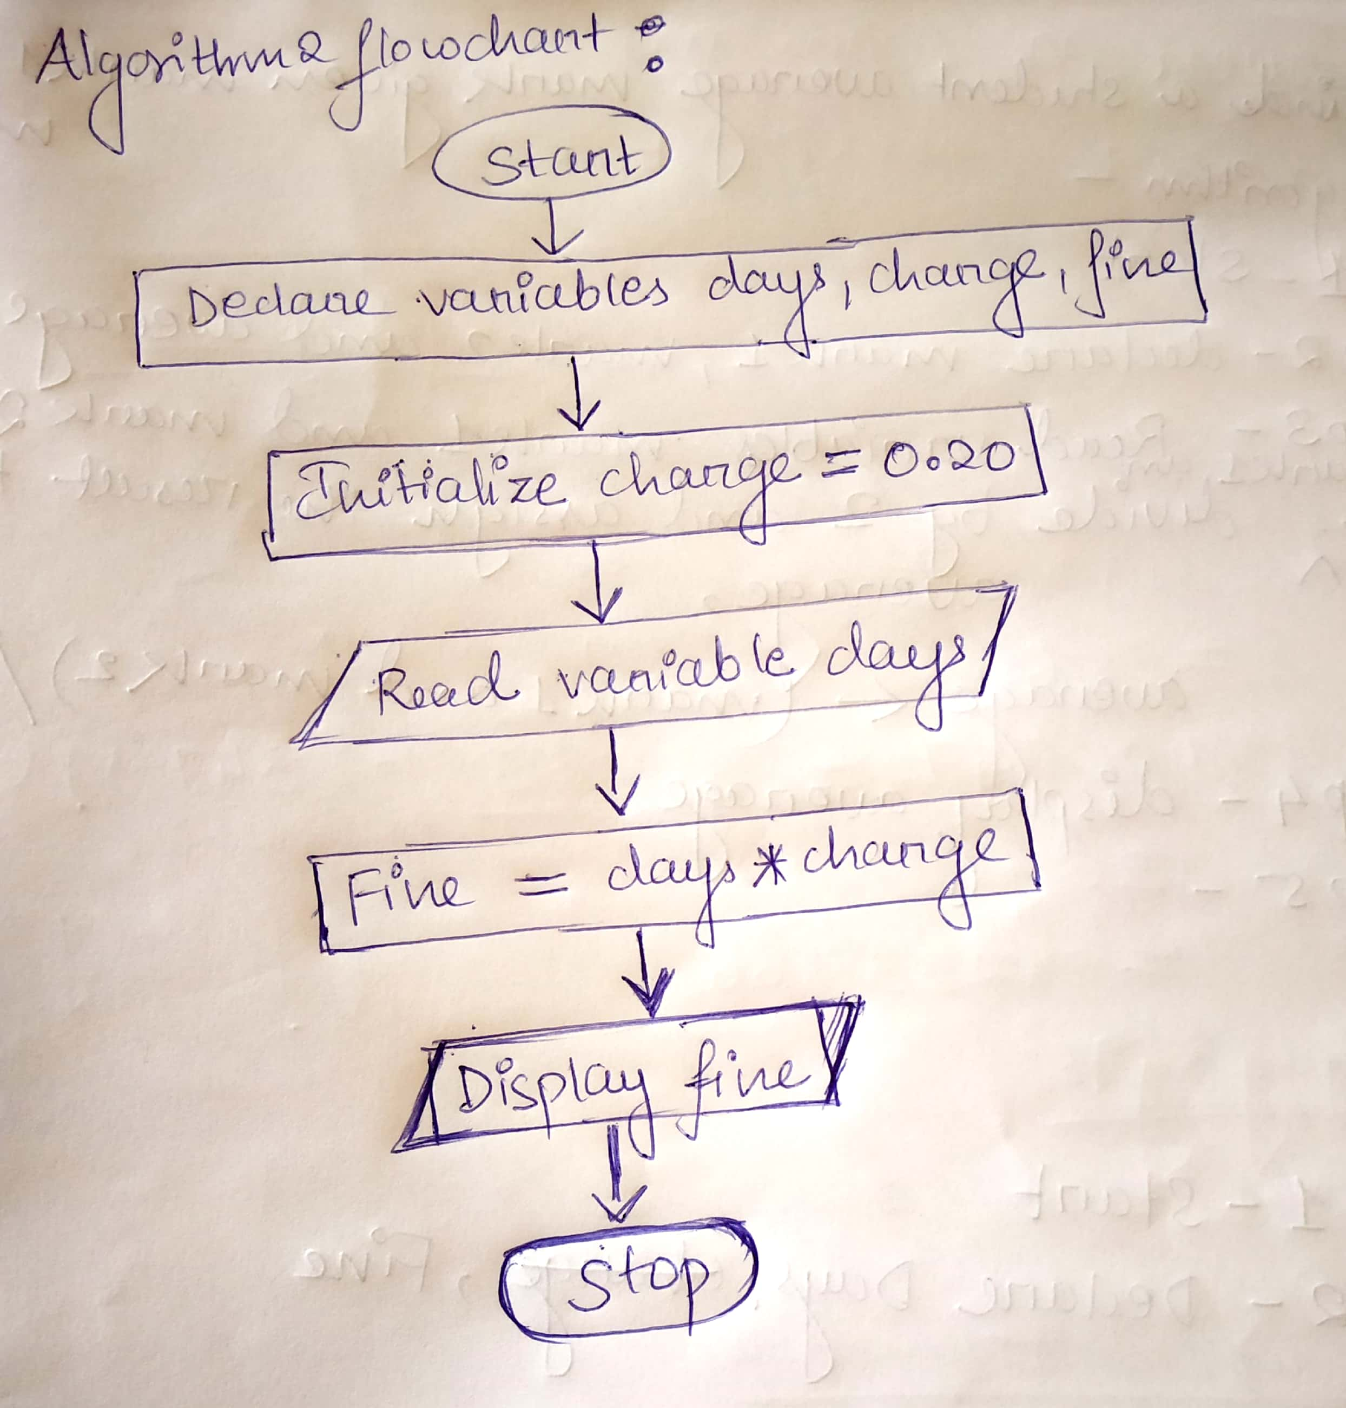

**3. you had bought a nice shirt which cost Rs.29.90 exclusive of 15% discount. Count the discounted price for the shirt.**

Algorithm :

Step1- start

Step2- declare variables cost, discount, discounted price and net price

Step3- initialise variables cost =29.9 and discount=15

Step4- multiply cost and discount and divide by 100 and  assign the result to discounted price

Discounted price<-- cost*discount/100

Step5 - subtract discounted price from cost and assign result to net price

Net price<-- cost - discounted price

Step6- display net price

Step7- stop

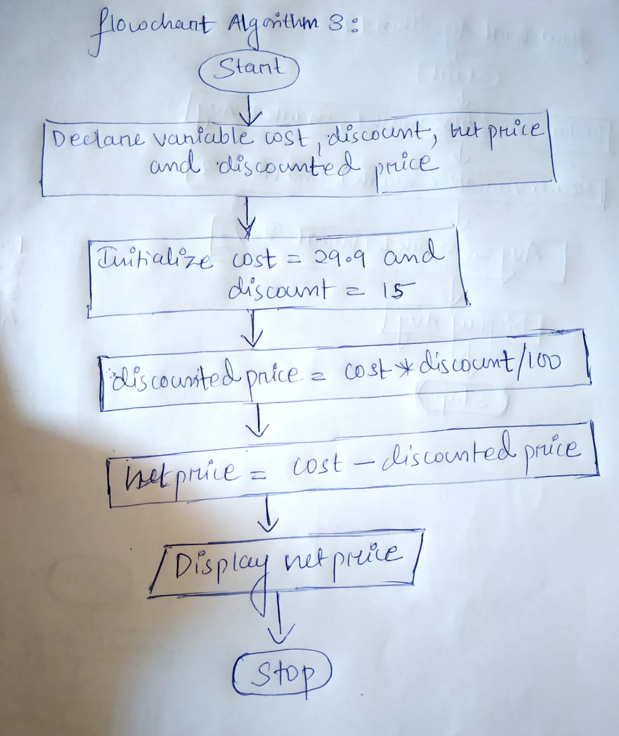

**4.find the smallest number among three different numbers.**

Algorithm :

Step1- start

Step2- declare variables a,b and c

Step3- read variables a,b and c

Step4- if a<b

                If a<c

  Display a is the smallest number

                Else

  Display c is the smallest number

            Else

                 If b<c

  Display b is the smallest number

                 Else

  Display c is the smallest number

Step5- stop

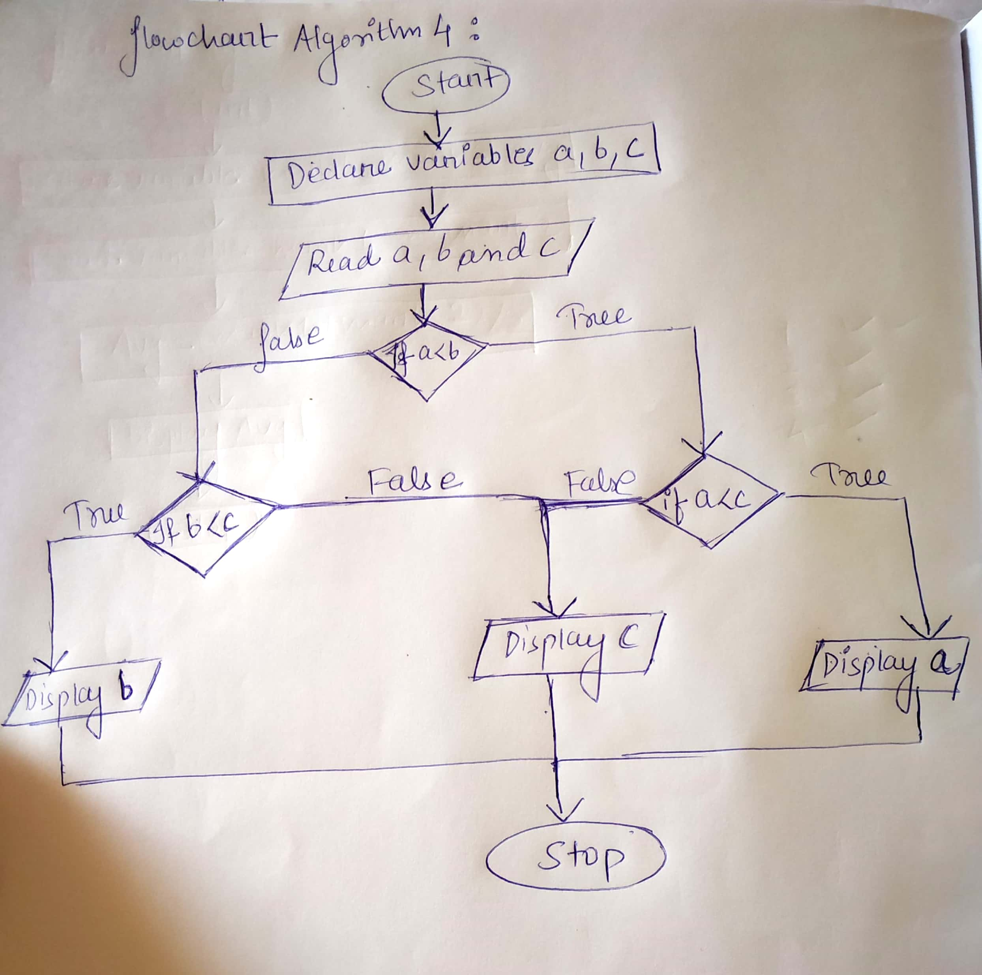

**5. find the roots of a quadratic equation ax^2+bx=c=0.**

Algorithm :

step1- Start

 Step2-  Declare  variables a,b,c,discriminant,root1 and root2

Step3- Read variables a,b and c

Step4-calculate discriminant

 discriminant=b*2-4*a*c

Step5- if discriminant<0

         Display roots are imaginary

           else

Calculate root1 and root2

 root1 =(-b+ sqrt(Discriminant))/2*a

 root2=(-b-sqrt(Discriminant))/2*a

 Display roots are root1 and root2

Step6- Stop

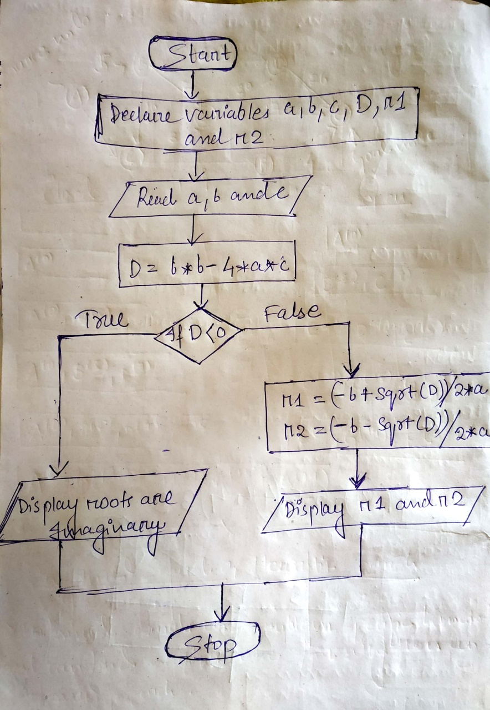

**6.find the factorial of a given number.**

Algorithm:

Step1- start

Step2- declare variables factorial ,number

Step3- initialize factorial=1

Step4- read variable number

Step5- if number n>=1

             Calculate factorial and number

and goto step5

              Factorial= factorial*number

             number=number-1

     Else

Display factorial

Step6- stop

